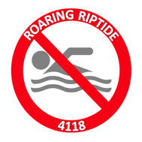2017-2018
FRC 4118: Roaring Riptide (Robotics Club)
Student Application for Returning & New Members
By way of completing and returning this application, students and parents agree to the following expectations:
- A member of this club will be a current P.K. Yonge student in 9th-12th grade who is in good academic standing.
- Space in this club is not limited, but student applications will be chosen based on the quality of his/her application form, accompanying student letter, and also the teacher recommendation form.
- A completed application, a letter by the student explaining why he/she is interested in the Robotics Club, and the attached Teacher Recommendation form are due no later than September 1, 2017. Forms should be returned to Ms. Brewster in Building Q Room 501.
- Teacher recommendation forms must be turned in to Ms. Brewster by the recommending teacher and not the student.
- Students and/or parents must provide transportation home from club meetings. Please ensure that your child is picked up on time, as sponsors & mentors have other obligations to attend to after meeting times.
CLUB MEETING ATTENDANCE & EXPECTATIONS:
- Meetings will take place in the Riptide Workspace during Power Hour the FIRST and THIRD Friday of each month (11:45-12:45).
- Meetings will also take place in the Riptide Workspace on the SECOND and FOURTH week of the month on Wednesdays and Thursdays from 2:30-5:30 (excluding HOLIDAY and NON-STUDENT DAYS from the school’s schedule.)
- During Build Season (first week of January for approximately six weeks), members will need to plan to stay after school EVERY DAY - with some weekend hours as well to complete the build of the robot, pit space, team spirit, and any other team projects for the competition. In order to attend the Orlando Regional event, the student is EXPECTED to be at no less than ¾ of meetings during the pre-season and Build Season combined.
In order to maintain your membership with the club:
- You must consistently attend club meetings.
- You are expected to be attentive and respectful to all fellow members, mentors, and other adults working with the club.
- You are expected to work diligently and collaboratively.
- You will maintain passing grades in all classes.
- You must use care and follow ALL safety precautions when using tools and equipment. Any horseplay will result in a warning. More than 3 consecutive warnings can/will result in dismissal from the club.
- You will NOT receive any major discipline referrals.
Club Sponsor:
If you need more information or have any questions regarding the Roaring Riptide Robotics Club, please contact our club sponsor.
Leigh Anne Brewster
labrewster@pky.ufl.edu

Follow Us on Social Media!

Twitter: @FRCRiptide4118
Instagram: frcriptide4118
Facebook: facebook.com/frcriptide4118

Team Calendar and Website: www.riptiderobotics.com (soon to change to a new URL)

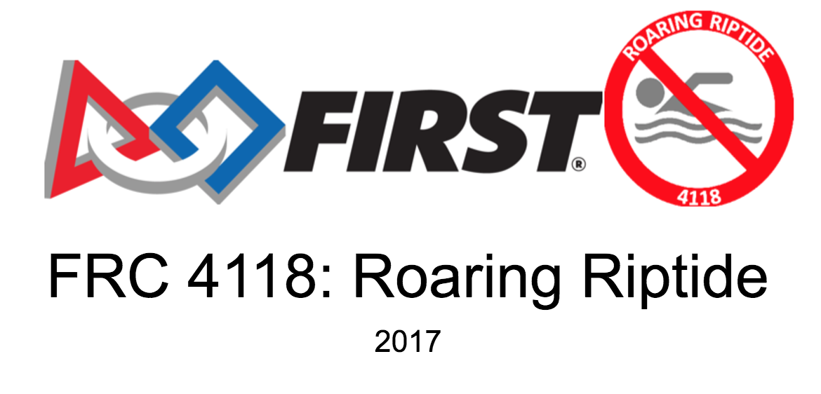

2017-18 Roaring Riptide (Robotics Club) Student Application Form

Student First Name: ________________________________________________________________________

Student Last Name: ________________________________________________________________________

Street Address: ___________________________________________________________________________

City/State/Zip: ____________________________________________________________________________

Home Phone: _________________________________Cell Phone: ___________________________________

Student Schedule: (Please write teacher’s last names in order by class period)

A Day | B Day
1 | 4
2 | 5
3 | 6

Alternative Schedule (Dual-Enrolled FT or PT) – Please Write In Your Schedule Below

Student Email: _____________________________________________________________________________

Have you Signed-Up for our Remind Communications? Yes/No ____________________________________

T-Shirt Size: _________ Shorts Size: ___________Favorite Snack Food: _____________________________

Allergies or Dietary Restrictions: ______________________________________________________________

I, _______________________________________________, understand that I must maintain passing grades, not receive any discipline referrals, work diligently and collaboratively with other club members, and use care with equipment to maintain my membership with the Roaring Riptide Robotics Club.

I also understand that I must attend at least ¾ of club meetings and club events.

Student Signature: __________________________________________Date: _________________________

Parent/Guardian #1

First Name: _____________________________________Last Name_________________________________

Address (if different than student): ____________________________________________________________

Mailing Address (if different from the street address): ____________________________________________

Home/Cell Phone: ____________________________________Work Phone: __________________________

E-mail: ___________________________________________________________________________________

Have you Signed Up for Remind Communication Updates? Yes/No (Please circle one)

Do you give consent for your child’s picture to be taken and used on our team’s social media, website, and any other communication announcements? Yes/No (Please circle one)

Parent/Guardian #2 (if applicable)

First Name: ________________________________________Last Name______________________________

Street Address (if different than student): ______________________________________________________

Mailing Address (if different from the street address): ____________________________________________

Home/Cell Phone: ____________________________________Work Phone: __________________________

E-mail: ___________________________________________________________________________________

Have you Signed Up for Remind Communication Updates? Yes/No (Please circle one)

Do you give consent for your child’s picture to be taken and used on our team’s social media, website, and any other communication announcements? Yes/No (Please circle one)

Does your child have any known allergies? If yes, please explain: ___________________________________ _________________________________________________________________________________________

If applicable, list any student medical conditions: __________________________________________________________________________________________

List any other important information concerning your child: __________________________________________________________________________________________
I give my son/daughter permission to participate in the Roaring Riptide Robotics Club. I understand that my child must follow all requirements to maintain their membership in the club and be eligible for events.

Parent Signature(s): ____________________________________________Date________________________

_____________________________________________________________Date________________________

2017-18 Roaring Riptide (Robotics Club) Application Form

Teacher Recommendation Form

Student Name: ____________________________________________________________________________

Teacher Name: ____________________________Grade: ______________ Subject: ____________________

Length of time you have known the student candidate: ___________________________________________

Please rank the student candidate on the following attributes by circling the appropriate number.
(1=poor, 2=below average, 3 = average, 4=good, 5=outstanding)

Attribute | Rank
Responsibility | 1 2 3 4 5
Persistence/Determination | 1 2 3 4 5
Cooperativeness | 1 2 3 4 5
Academic Ability | 1 2 3 4 5
Creativity | 1 2 3 4 5

Please describe the strengths this candidate would bring to Roaring Riptide Robotics Club:

______________________________________________________________________________________________________________________________________________________________________________________________________________________________________________________________________________Please describe any areas of improvement for this student: ____________________________________________________________________________________________________________________________________________________________________________________
Teacher Signature: ___________________________________________________Date: _________________

Please return this form to Ms. Brewster in Q-501. Please fold this form in half, and staple or tape. Your recommendation will remain confidential.

Fundraising Commitment Form

Just like other clubs at P.K., we are asking each member of the Roaring Riptide (Robotics Club) to understand and commit to assisting with fundraising and grant writing. As many of you who are already on the team know, it takes several thousand dollars for our team to build the robot, travel to competitions, purchase spirit wear, and overall, have a successful season.

This year, we did not receive the large grant from Best Buy, as the company changed the date for the submissions without notifying anyone. Therefore, this year, more than ever, we need your help!

We will collectively be relying on our mentors, students, and sponsors to help us with our fundraising and grants efforts for this year.

We are asking that you understand this commitment and be willing to work on items such as grant writing or visiting local businesses to assist us in getting sponsors. Ms. Brewster will be the lead in working with businesses, but may ask that you stop by or call and tell them about our club and its purpose at some point in the season.

By signing the Fundraising Commitment Form below, you are acknowledging and committing to help with our fundraising efforts.

_______________________________________________________________________
Student Signature Date

_______________________________________________________________________
Parent/Guardian Signature Date

